# **SOFTWARE TESTING**

**(Sample File)**

## **7.1 Test Cases**

Test Cases are essential in ensuring the quality and dependability of Taskify. Test cases are precise, step-by-step instructions meant to ensure that the system works as expected in a variety of circumstances. They serve as a methodical technique to ensuring that each system feature, functionality, and need fits its original requirements.

## **7.1.1 TC01 - Sign Up**

This test case verifies that a user can successfully register by providing valid details in the registration form, clicking the “Sign Up” button, and completing the email verification process.

**Traceability Matrix Reference**

4.2: FR-1: User Registration and Authentication



**Test Case**

*Table 29: TC01 - Sign Up*

| **Test Case ID** | **Test Case Description** | **Preconditions** | **Test Steps** | **Expected Results** | **Actual Results** | **Status** |
| --- | --- | --- | --- | --- | --- | --- |
| SU-01 | Valid Registration | User is on the sign-up page | 1. Enter valid details in the registration form (name, email, password). | User account is created successfully. | User account is created successfully. | Pass |
| 2. Click "Sign Up" button. | Verification form show. | Verification form show. |
| 3. Verify the email and complete the verification process. | User verified successfully. | User verified successfully. |

| SU-02 | Missing Name | User is on the sign-up page | 1. Leave the name field blank. | Error message is displayed indicating the missing field. | Error message is displayed indicating the missing field. | Pass |
| --- | --- | --- | --- | --- | --- | --- |
| 2. Enter valid email and password. |
| 3. Click "Sign Up" button. |
| SU-03 | Invalid Email Format | User is on the sign-up page | 1. Enter an invalid email address format (e.g., missing @ symbol). | Error message is displayed indicating an invalid email format. | Error message is displayed indicating an invalid email format. | Pass |
| 2. Enter valid name and password. |
| 3. Click "Sign Up" button. |
| SU-04 | Existing Email | User is on the sign-up page | 1. Enter an email address that is already registered. | Error message is displayed indicating the email is already in use. | Error message is displayed indicating the email is already in use. | Pass |
| 2. Enter valid name and password. |
| 3. Click "Sign Up" button. |

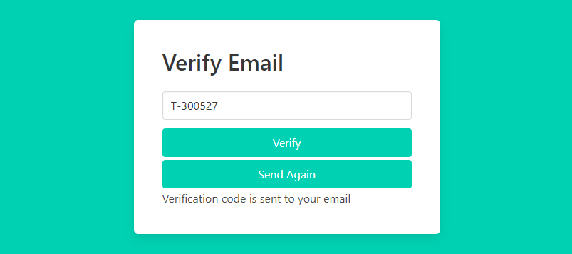



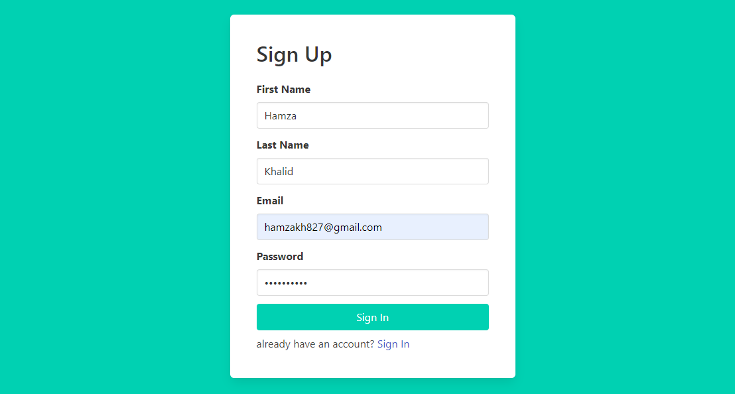



## **7.1.2 TC02 - Log In**

This test case confirms that a user may log in successfully by entering valid username and password credentials, pressing the “Log In” button, and being sent to the dashboard or homepage.

**Traceability Matrix Reference**

4.2: FR-1: User Registration and Authentication

**Test Case**

*Table 30: TC02 - Log In*

| **Test Case ID** | **Test Case Description** | **Preconditions** | **Test Steps** | **Expected Results** | **Actual Results** | **Status** |
| --- | --- | --- | --- | --- | --- | --- |
| LI-01 | Valid Credentials | User is on the login page | 1. Fill up the login form with a valid username and password. | The user has been successfully signed in and is being sent to the dashboard/homepage. | The user has been successfully signed in and is being sent to the dashboard/homepage. | Pass |
| 2. Click "Log In" button. |
| LI-02 | Missing Email | User is on the login page | 1. Leave the email address field empty. | The missing field is shown with an error message. | The missing field is shown with an error message | Pass |
| 2. Enter a correct password. |
| LI-03 | Missing Password | User is on the login page | 1. Enter valid email. | The missing field is shown with an error message. | The missing field is shown with an error message. | Pass |
| 2. Leave the password field blank. |
| 3. Click "Log In" button. |
| LI-04 | Invalid Credentials | User is on the login page | 1. In the login box, provide an incorrect email and password combination. | An error message indicating incorrect credentials is presented. | An error message indicating incorrect credentials is presented. | Pass |
| 2. Select the "Log In" option. |



